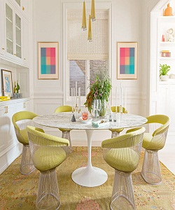

Lexington Dining Table

$182.55

Availability: In stock

Description

Gorgeous Tulip Table with iconic Planter armchairs in the dining room, bold pendants with golden glint. The table is made of quality material and have glass varnish. The 6 chair set of wood frame and soft fabric different color range is available. Non –assembly required.